Batch:14
2403a51349
ASSIGNMENT:2.1

Task Description #1
- Use Google Gemini in Colab to write a Python function that reads a list of numbers and calculates the mean, minimum, and maximum values.

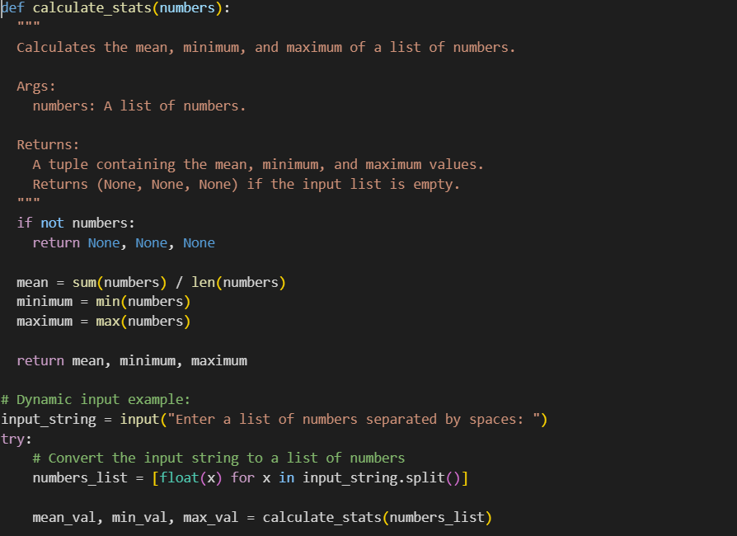
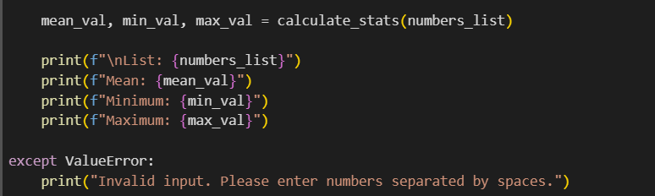

Output:
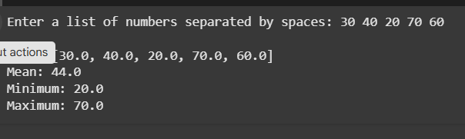

Task Description #2
- Compare Gemini and Copilot outputs for a Python function that checks whether a number is an Armstrong number. Document the steps, prompts, and outputs.
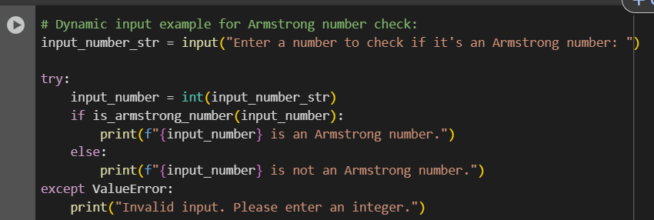
Output:
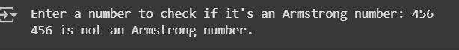
Side-by-side comparison table :
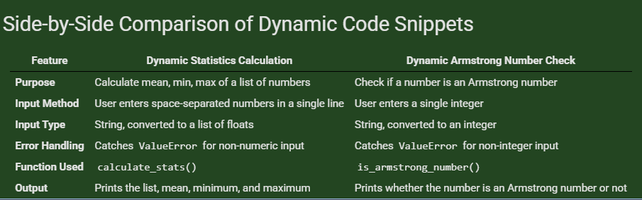

Task Description #3
- Ask Gemini to explain a Python function (e.g., is_prime(n) or is_palindrome(s)) line by line.
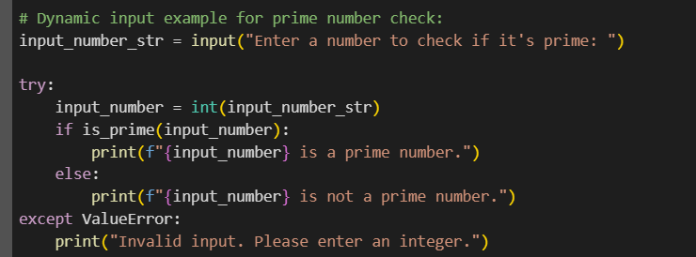
Output:
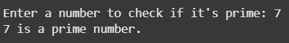

Task Description #4
- Install and configure Cursor AI. Use it to generate a Python function (e.g., sum of the first N natural numbers) and test its output.
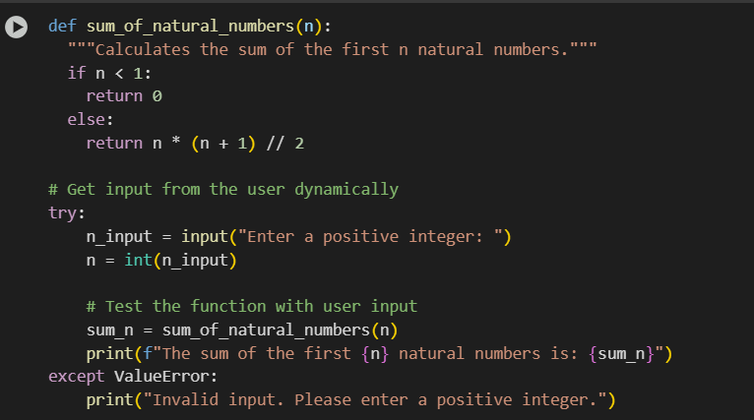

Output:


Task Description #5
Students need to write a Python program to calculate the sum of odd numbers and even numbers in a given tuple

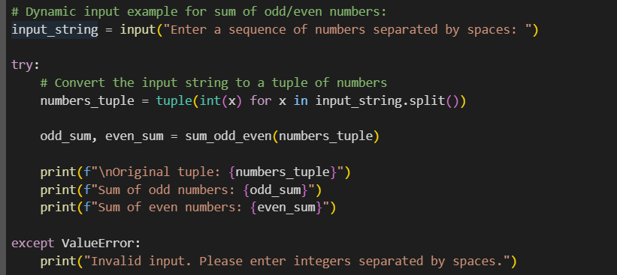

Output:
